Functional Specification Document

PROJECT: MVP 2 Farming Engagement Hub
EPIC: Farmer Segmentation
Functionality: Farmer Irregularities KPI — Processing and Registration
User Story ID: PA-SEG-003
Functional Specification For: (X) Web Application ( ) Mobile Application
Portal: Back Office PA (Web)
Prototype: BAT - Agri 360 — Figma (segmentation flows)

Contents
- 1. Revision History
- 2. Sign-off
- 3. Process Specification
- 4. User Interface & User Experience
- 5. Policy & Regulatory Requirements
- 6. Technical Requirements
- 7. Positive & Negative Testing

1. Revision History
Date | Name | Change | Version
26/05/2026 | Matheus Kist | Initial document draft | 1.0

2. Sign-off
All screens described in this document are operated by the Backoffice PA User within the Back Office PA portal.
Date | Name | Role

3. Process Specification
- What? Record ESG/compliance irregularity events per farmer, crop season, and culture type.
- Who? Backoffice PA User.
- When? When irregularities are known and before ESG scoring simulations.
- Where? KPI Data — ESG Irregularities screen (Web); user story name: Farmer Irregularities KPI.
- Why? Irregularities are multi-valued and separate from contract KPI percentages.
- How? Grid, manual maintenance, import (Phase 1); Agri360-fed data (Phase 2).

3.2 Phased behaviour
Phase | Behaviour
Phase 1 (MVP) | Manual grid maintenance and file import only.
Phase 2 (target Agri360) | Irregularity events captured by Agri360 compliance and ESG processes are written to this KPI store through scheduled routines. Rows are frozen with calculation metadata; the UI is read-only except for authorised overrides.

3.3 Scoring link
Segmentation configuration assigns a score per irregularity type. At simulation, irregularities in the latest active ESG scope season add to the ESG component together with reforestation and native forest percentages from Farmer Contract KPI.

3.4 Data requirements
Field | Required | Description
Farmer code | Yes | Farmer business key.
Crop season | Yes | Crop season.
Culture type | No | Default FCV.
Irregularity type | Yes | Catalogue reference.

4. User Interface & User Experience

4.1 SCREEN 01: KPI Data — ESG Irregularities (Web)
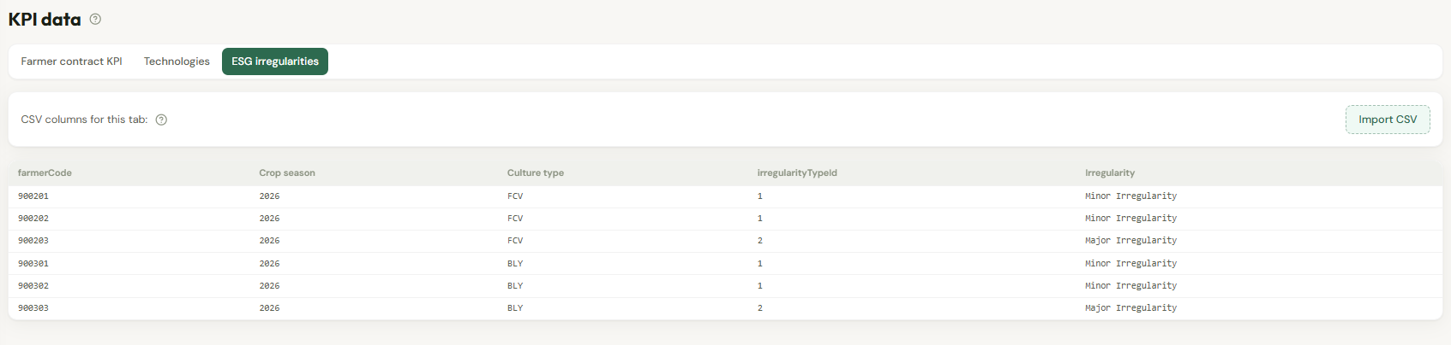
Figure 1 — Wireframe: ESG irregularities (Farmer Irregularities KPI) screen.

- Same interaction pattern as Technologies: grid, add, delete, import.
- Import columns: Farmer code, Crop season, Culture type (optional), Irregularity type.
- Tooltip: reforestation/native forest % maintained on Farmer Contract KPI; events maintained here.

5. Policy & Regulatory Requirements
ESG data may be sensitive — restrict by role. Align with environmental compliance policies (Legal TBD).

6. Technical Requirements

6.1 Automations
- Phase 1: none (manual and import only).
- Phase 2: scheduled sync from Agri360 compliance / ESG case closure.

7. Positive & Negative Testing
ID | Scenario | Expected result
T-01 | Import irregularity | ESG simulation includes configured score when type matches.
T-02 | Multiple irregularities | Scores aggregate per configuration rules.
T-03 | No irregularities | Only reforestation/native forest portion applies.

